 | CS402- Theory of Automata  ASSIGNEMN-2  JUNAID MALIK | 
BC190202640@vu.edu.pk  Junaidfazal08@gmail.com | For More Visit: vulmshelp.com | JUNAID MALIK (0304-1659294)


Question No: 1
    - Consider the following sequential circuit.

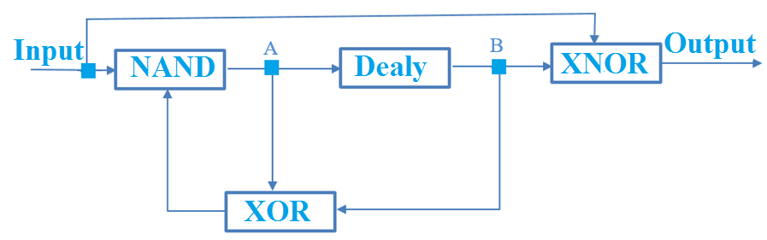

If
Input=0
Old A= 1
Old B= 0
Then find:
- New Value of A
- New Value of B
- Value of Output
Solution:

New B = old A = 1
New A = (input) NAND (old A XOR old B)
New A = 0 NAND (1 XOR 0) = 0 NAND 1= 1
Output = (input) XNOR (old B) = 0 XNOR 0 = 1

    - Consider the following TG₁ and TG₂ and find the resultant TG_{r} which is equal to the Union of TG₁ and TG₂.
TG1:
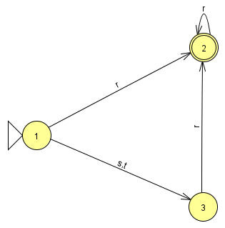

TG2:
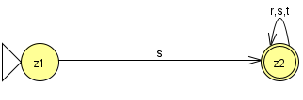

Solution:

TGr
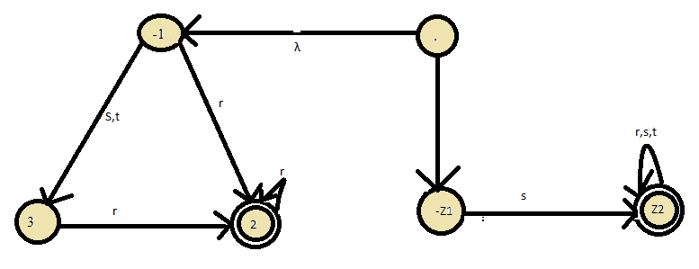

Question No: 2

- Find the intersection of the following FAs by short method. Also provide transition table and Transition diagram as well.

FA1:
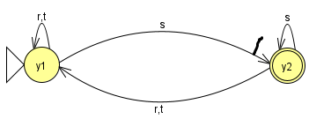
FA2:
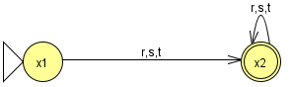
Transition Table:

Old state | New state
Old state | R | S | T
-z1 = (x1,y1) | Z3= (x2,y1) | Z4 = (x2,y2) | Z3 = (x2,y1)
Z2= (x1,y2) | Z3= (x2,y1) | Z4 = (x2,y2) | Z3 = (x2,y1)
Z3=(x2,y1) | Z3= (x2,y1) | Z4 = (x2,y2) | Z3 = (x2,y1)
+Z4=(x2,y2) | Z3= (x2,y1) | Z4 = (x2,y2) | Z3 = (x2,y1)

Transition diagram:

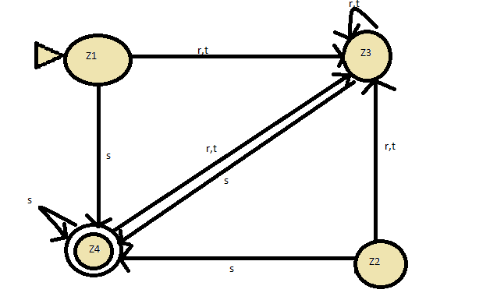

b) Find the complement of the FA obtained in Part(a):

